**How To Execute Maven Project Using Jenkins**

Firstly install Maven in Eclipse IDE and create a Maven Project. Next, open Jenkins and create a new Job to execute Maven Project using Jenkins.

## Execute Maven Project Using Jenkins:

In this article, we see how to execute maven project using jenkins.

Click on **New Item** link to create a job on Jenkins

[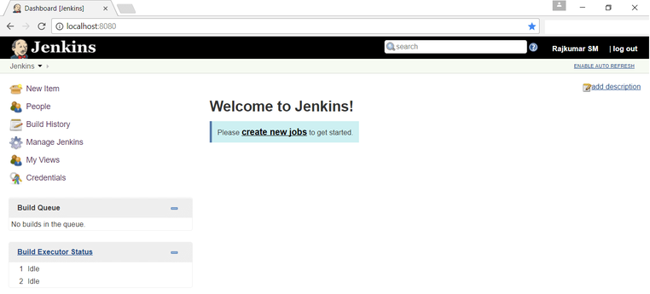](https://www.softwaretestingmaterial.com/wp-content/uploads/2017/08/install-jenkins-12.png)

Enter an item name (here I am adding a name ‘MavenProject’) and click on FreeStyle Project and click on OK

[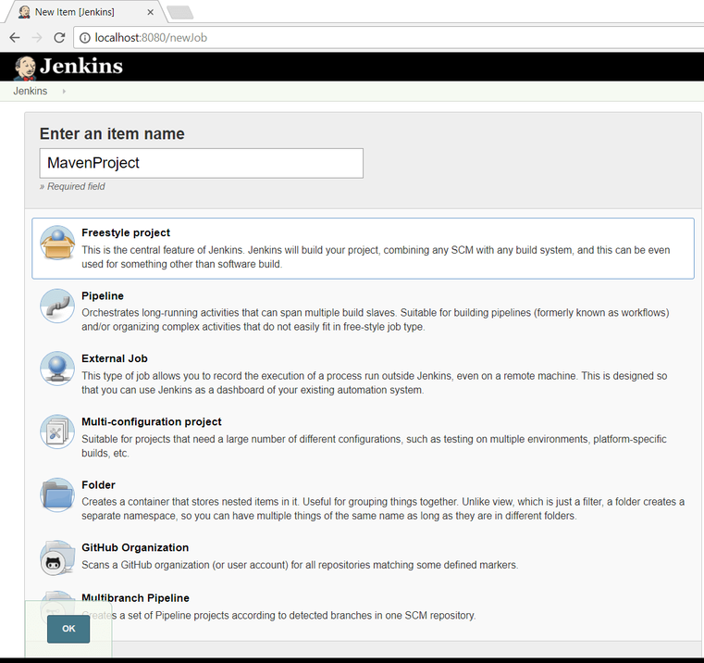](https://www.softwaretestingmaterial.com/wp-content/uploads/2017/08/install-jenkins-13.png)

Scroll down to ‘**Build**‘ option. Click on ‘**Add Build Step**‘ and choose the value ‘**Invoke top-level Maven targets**‘ from the drop down list.

Enter Goals “**clean install**”

Enter POM path (in my case the path is D:\STM\STMBlog\workspace\MavenProject\pom.xml)

Click on ‘**Apply**‘ and ‘**Save**‘

[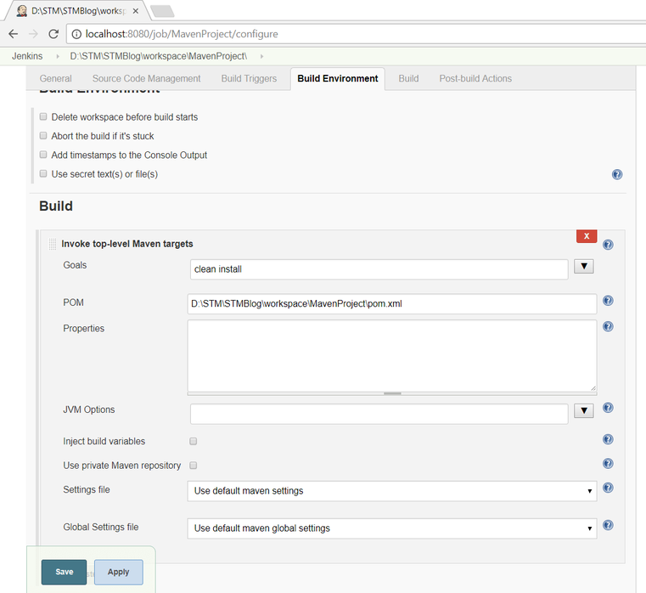](https://www.softwaretestingmaterial.com/wp-content/uploads/2017/08/install-jenkins-14.png)

We have created a new project ‘**MavenProject**‘ with the configuration to execute Maven Project using Jenkins. You could see in the below screenshot.

[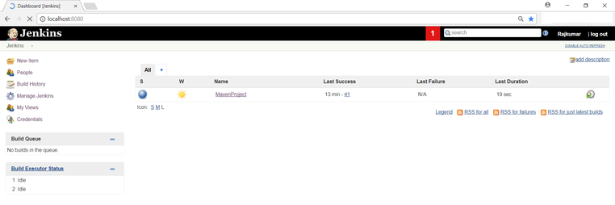](https://www.softwaretestingmaterial.com/wp-content/uploads/2017/08/install-jenkins-15.png)

Let’s execute it now. Click on ‘**Build Now**‘ button. It will invoke pom.xml.

[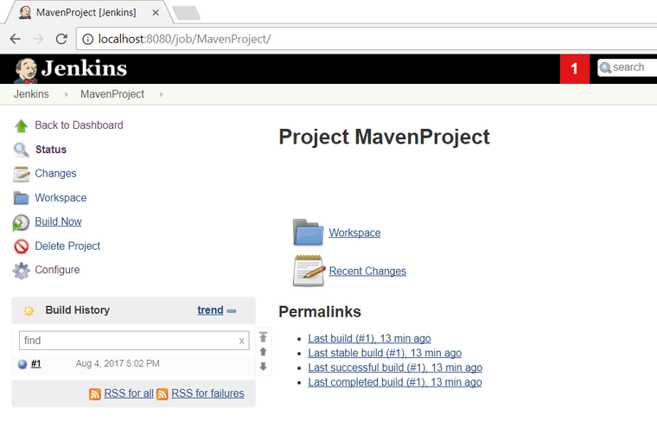](https://www.softwaretestingmaterial.com/wp-content/uploads/2017/08/install-jenkins-16.png)

Right click on Build Number (here in my case it is #1) and click on Console Output to see the result.

[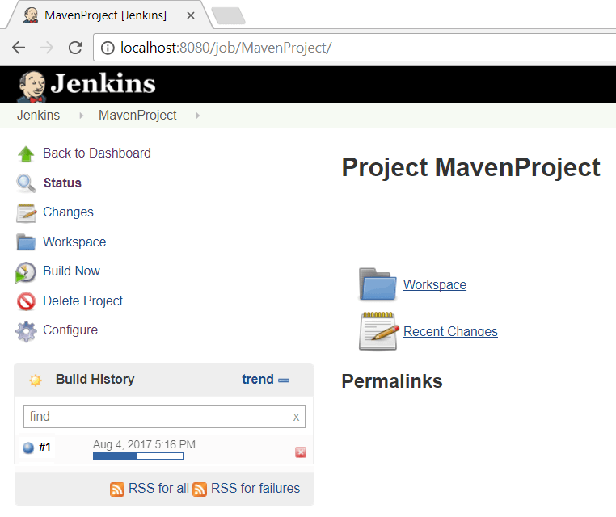](https://www.softwaretestingmaterial.com/wp-content/uploads/2017/08/install-jenkins-17.png)

You could see Build Status ‘Success’ on Console Output.

[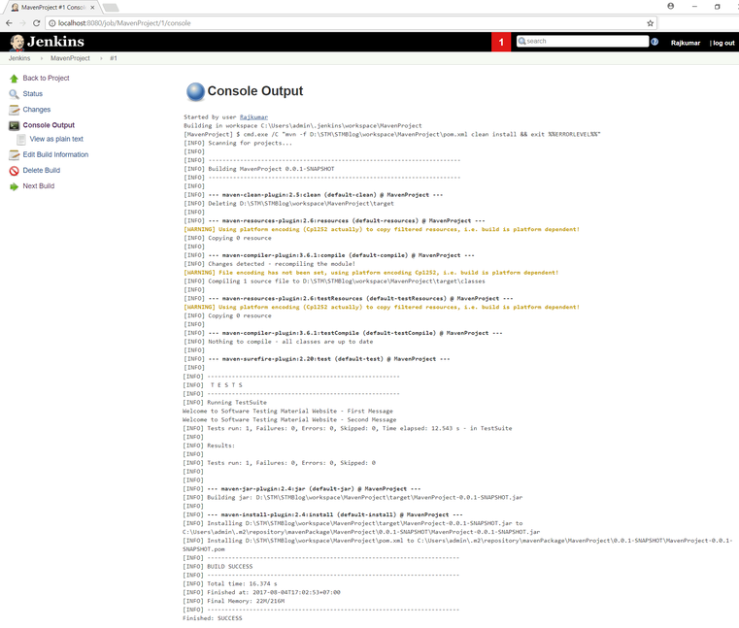](https://www.softwaretestingmaterial.com/wp-content/uploads/2017/08/install-jenkins-18.png)